Project Design Phase
Solution Architecture
Date | 18 June 2026
Team ID | N/A
Project Name | Book-A-Doctor Healthcare Appointment Management System
Maximum Marks | 4 Marks

Solution Architecture
The Book-A-Doctor Healthcare Appointment Management System is built using the MERN stack (MongoDB, Express.js, React.js and Node.js). The architecture connects Patients, Doctors and Administrators through a secure web platform for appointment booking, doctor management, medical record handling, notifications and reporting.
• Find the best technology solution for healthcare appointment management.
• Describe system structure, behavior and interactions.
• Define development phases and solution requirements.
• Provide implementation specifications and deployment guidance.

Book-A-Doctor Solution Architecture Diagram
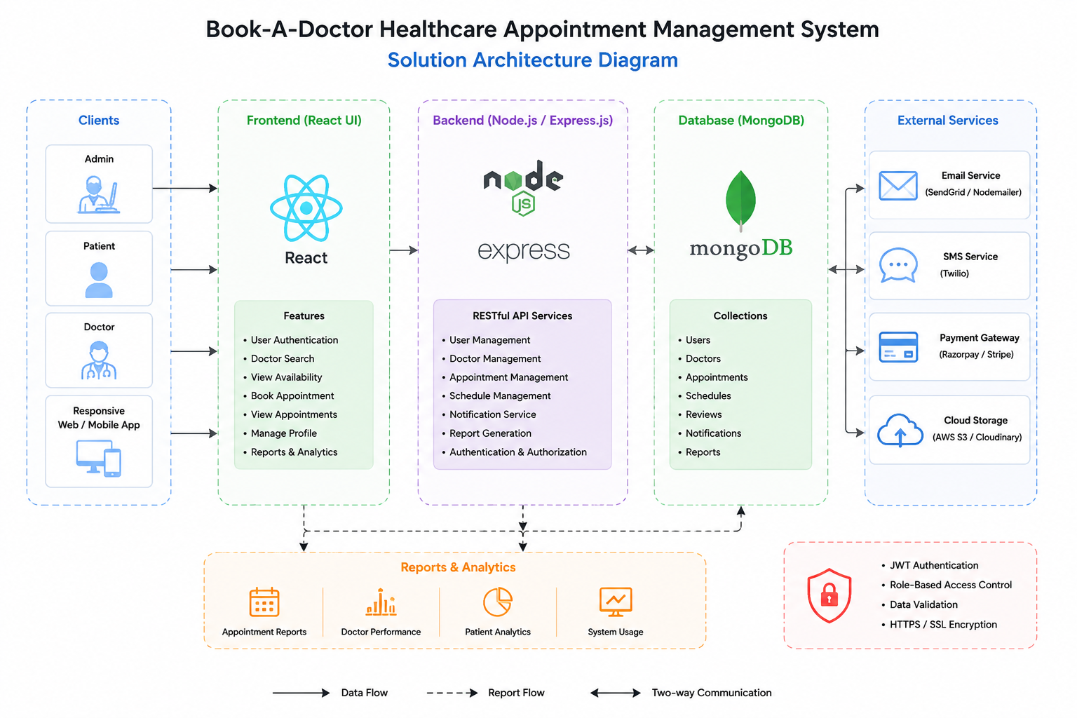
Figure 1: Book-A-Doctor Healthcare Appointment Management System Architecture

References
https://react.dev/
https://nodejs.org/
https://expressjs.com/
https://www.mongodb.com/docs/
https://jwt.io/

